Tab 2
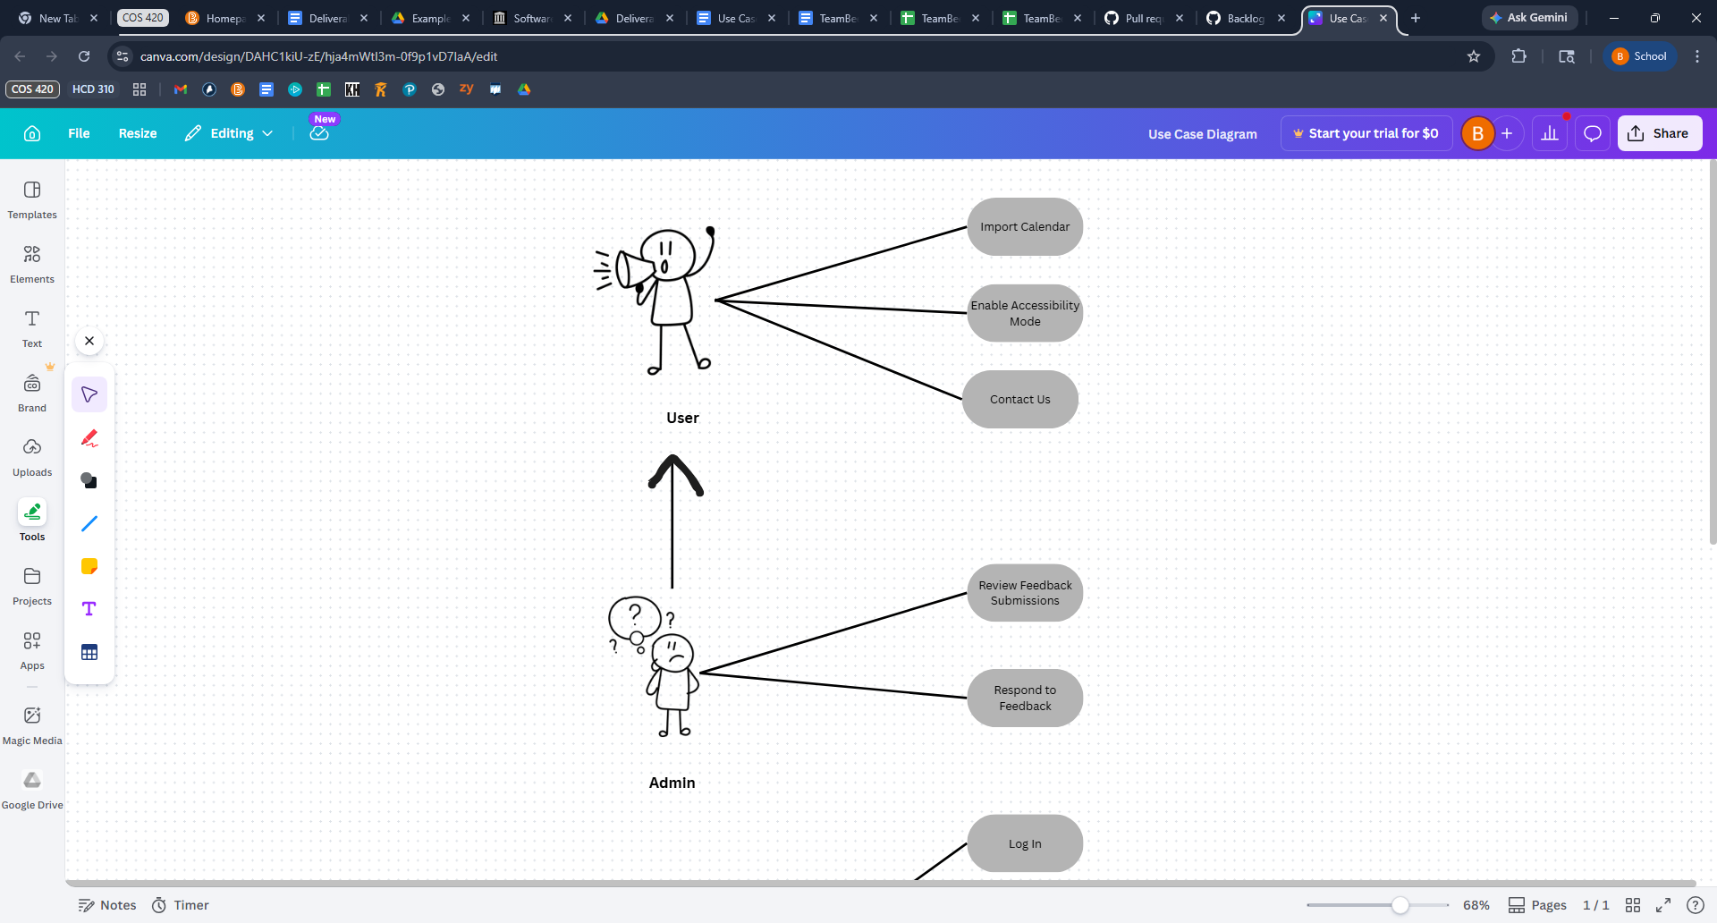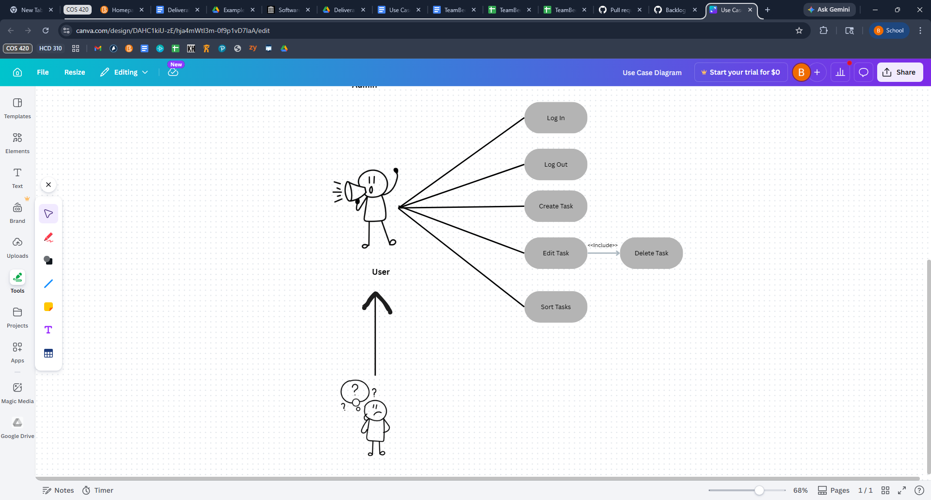

Name/Title: | Log In
ID: | UC-1
Description: | Users log in to their accounts to see their information.
System Under Design: | LogInButton
Primary Actor: | User
Goal: | Allow the user to log in to their account securely.
Related Use Cases:

USER STEPS:  1. User presses the login button  3. User enters login info  4. User presses confirm button | SYSTEM RESPONSE:  2. System prompts user to enter account info  5. System checks login info  6. System logs user into their account

Name/Title: | Create Task
ID: | UC-2
Description: | Users add their tasks to their calendar, along with all of the task info they want.
System Under Design: | AddTaskButton
Primary Actor: | User
Goal: | User will be able to add their task to their calendar.
Related Use Cases:

USER STEPS:  1. User presses Add Task button  3. User enters all task info they want to  4. User presses confirm add | SYSTEM RESPONSE:  2. System prompts user to task event info  5. System adds the task to the calendar

Name/Title: | Delete Task
ID: | UC-3
Description: | Remove a selected task from the calendar.
System Under Design: | RemoveTaskButton
Primary Actor: | User
Goal: | Users will be able to remove a task from their calendar.
Precondition: | There must be at least one task that exists.
Related Use Cases: | Edit Task

USER STEPS:  1. User selects a task in their calendar  3. User presses the delete task button  5. User confirms they want to delete it | SYSTEM RESPONSE:  2. System displays a detailed view of the task  4. System displays confirmation button  6. System removes task from the calendar

Name/Title: | Contact Us
ID: | UC-4
Description: | Contact information for the company is shown.
System Under Design: | ContactUsButton
Primary Actor: | User
Goal: | Allow the user to contact support.
Related Use Cases:

USER STEPS:  1. User presses the Contact Us button | SYSTEM RESPONSE:  2. System displays the contact information

Name/Title: | Log Out
ID: | UC-5
Description: | Logs the user out of their event.
System Under Design: | LogOutButton
Primary Actor: | User
Goal: | Allow the user to log out of their account securely.
Related Use Cases:

USER STEPS:  1. User presses the log-out button | SYSTEM RESPONSE:  2. System logs the user out of their account

Name/Title: | Import Calendar
ID: | UC-6
Description: | Import a previously made calendar from a different application supporting a common family type.
System Under Design: | ImportCalendarButton
Primary Actor: | User
Goal: | Allow the user to import a calendar from another application.
Related Use Cases:

USER STEPS:  1. User presses import calendar button  3. User selects a file  5. User confirms file selection | SYSTEM RESPONSE:  2. System prompts user to select a file  4. System prompts user to confirm their selection  6. System reads the selected file  7. System parses throught the file  8. System adds events from the parsed data

Name/Title: | Enable Accessibility Mode
ID: | UC-7
Description: | Enable the accessibility settings to be able to make the app accessible for most colorblind people.
System Under Design: | AccessabilitySettings
Primary Actor: | User
Goal: | Enable the accessibility setting
Related Use Cases:

USER STEPS:  1. User presses accessibility button  3. User selects colorblind mode | SYSTEM RESPONSE:  2. System turn opens accessibility settings  4. System changes colors to be visible to people with the selected type of colorblindness

Name/Title: | Edit Task
ID: | UC-8
Description: | User edits a task that has already been created.
System Under Design: | EditTaskButton
Primary Actor: | User
Goal: | Edit a task that already exists.
Precondition: | At least one task must already exist
Related Use Cases:

USER STEPS:  1. User selects a task that exists  3. User selects edit task button  5. User edits any parts of the task  6. User selects save edits button | SYSTEM RESPONSE:  2. System displays task options  4. System displays task edit page  7. Edits are saved to the task

Name/Title: | Sort Tasks
ID: | UC-9
Description: | Sorts the task by a selected criteria by the user.
System Under Design: | SortTasksButton
Primary Actor: | User
Goal: | Sort the tasks on the calendar
Related Use Cases:

USER STEPS:  1. User selects sort tasks button  3. User selects sort option | SYSTEM RESPONSE:  2. System displays menu with ways to sort tasks  4. System sorts tasks according to user choice  5. System displays newly sorted tasks

Name/Title: | Review Feedback Submissions
ID: | UC-10
Description: | Allows the administrators to review the feedback submisions
System Under Design: | ReviewFeedback
Primary Actor: | Admin
Goal: | Review the feedback submissions from users
Precondition: | Admin must be on the admin view screen
Related Use Cases:

USER STEPS:  1. Admin presses review feedback button | SYSTEM RESPONSE:  2. System requests list of feedback from the database  3. Database sends the feedback  4. System parses the feedback data  5. System displays the feedback

Name/Title: | Respond to Feedback
ID: | UC-11
Description: | Allows the admin to respond to the feedback from users
System Under Design: | RespondToFeedback
Primary Actor: | Admin
Goal: | Respond to the user feedback
Precondition: | Admin must be on admin view screen and there must be at least one piece of feedback.
Related Use Cases: | Review Feedback Submissions

USER STEPS:  1. Admin selects a given submission  3. Admin presses respond button  5. Admin types a response  6. Admin presses send button  8. Admin presses confirm | SYSTEM RESPONSE:  2. System displays a detailed view of the submission  4. System displays response window  7. System displays confirmation window  9. System sends response to the user

